Experiment 8

AIM: To calculate the convolution sum of two continuous-time signals

THEORY:
Convolution can be used to determine the output a system produces for a given input signal. It can be shown that a linear time invariant system is completely characterized by its impulse response. The sifting property of the discrete time impulse function tells us that the input signal to a system can be represented as a sum of scaled and shifted unit impulses. Thus, by linearity, it would seem reasonable to compute the output signal as the sum of scaled and shifted unit impulse responses. That is what the operation of convolution accomplishes. Hence, convolution can be used to determine a linear time invariant system's output from knowledge of the input and the impulse response.

Continuous time convolution is an operation on two continuous time signals defined by the integral :

If one signal has M length and other has N length then convolution of these two signals will have M+N length.

Finding Convolution Sum
- Define/Sketch x(t) and h(t).
- The impulse response, h(t) time -reversed or folded to obtain h(-t).
- Then h(-t) shifted by n to form h(n – t) = h(-(t- n)) which is a function of t with parameter n. Begin with shift n large and negative, i.e., shift h(-t) to the far left on the time axis.
- The signal x(t) and h(n – t) are multiplied together for all values of t with n fixed at some value/range.
- The product x(t) h(n – t) is summed over all t to produce a single output value y(n).
- For Calculating the response of the system over all instants of time, repeat steps 3 to 5 till response at all time instants (t = -∞ to ∞) is obtained.

=================================================================

IN LAB EXERCISES

1. Consider the continuous-time signals
, ,

Write a MATLAB program to perform and verify the discrete-time convolution commutativity, distributivity and associativity properties (Use conv):

clc;
clearvars;
syms t tau gamma;

% Declaring the symbolic functions to be used later
f_1 = dirac(t);
f_2 = triangularPulse(t);
f_3 = heaviside(t) - heaviside(t - 5);

% Plotting the base functions of which we will take
% the convolution of
my_tile = tiledlayout(3, 4);
title(my_tile, "\fontname{Inter}CT Convolutions - 22102109 - InLab - Q1");
nexttile(1, [1 2]);
fplot(f_1);
title("\delta(t)")

nexttile(5, [1 2]);
fplot(f_2);
ylim([-0.25 1.25])
title("\it tri(t)")

nexttile(9, [1 2]);
fplot(f_3, [-1 6]);
ylim([-0.5 1.5])
title("\it u(t) - u(t - 5)")

clearvars f_1 f_2 f_3;

% Part 1 -- Commutativity
f_1_tau = dirac(tau);
f_2_minus = triangularPulse(t - tau);
part_1_convolution_1 = int(f_1_tau * f_2_minus, tau, -Inf, Inf);
nexttile(3);
fplot(part_1_convolution_1)
ylim([-0.25 1.25])
title("\delta(t) * tri(t)");

f_2_tau = triangularPulse(tau);
f_1_minus = dirac(t - tau);
part_1_convolution_2 = int(f_2_tau * f_1_minus, tau, -Inf, Inf);
nexttile(4);
fplot(part_1_convolution_2)
ylim([-0.25 1.25])
title("\ittri(t) * \delta(t)")

% Part 2 -- Commutativity
f_23_minus = f_2_minus + (heaviside(t - tau) - heaviside(t - tau -5));
part_2_convolution_1 = int(f_1_tau * f_23_minus, tau, -Inf, Inf);
nexttile(7);
fplot(part_2_convolution_1, [-5 10])
ylim([-0.25 2.25])
title("\it\delta(t) * (tri(t) + u(t) - u(t - 5))")

f_3_minus = heaviside(t - tau) - heaviside(t - tau - 5);
part_2_convolution_2 = int(f_1_tau * f_2_minus, tau, -Inf, Inf);
part_2_convolution_2 = part_2_convolution_2 + int(f_1_tau * f_3_minus, tau, -Inf, Inf);
nexttile(8);
fplot(part_2_convolution_2, [-5 10])
ylim([-0.25 2.25])
title("\it\delta(t) * tri(t) + \delta(t) * (u(t) - u(t - 5))")

% Part 3 -- Associativity
f_2_gamma = triangularPulse(gamma);
f_3_tau_minus = heaviside(t - tau - gamma) - heaviside(t - tau - gamma - 5);
f_23_conv_t_tau = int(f_2_gamma * f_3_tau_minus, gamma, -Inf, Inf);
part_3_convolution_1 = int(f_1_tau * f_23_conv_t_tau, tau, -Inf, Inf);
nexttile(11);
fplot(part_3_convolution_1, [-5 10])
ylim([-0.5 1.5])
title("\it\delta(t) * (tri(t) * (u(t) - u(t - 5)))")

f_1_gamma = dirac(gamma);
f_2_tau_gamma = triangularPulse(tau - gamma);
f_12_tau = int(f_1_gamma * f_2_tau_gamma, gamma, -Inf, Inf);
part_3_convolution_2 = int(f_12_tau * f_3_minus, tau, -Inf, Inf);
nexttile(12)
fplot(part_3_convolution_2, [-5 10])
ylim([-0.5 1.5])
title("\it(\delta(t) * tri(t)) * (u(t) - u(t - 5))")
clearvars;

OUTPUT:
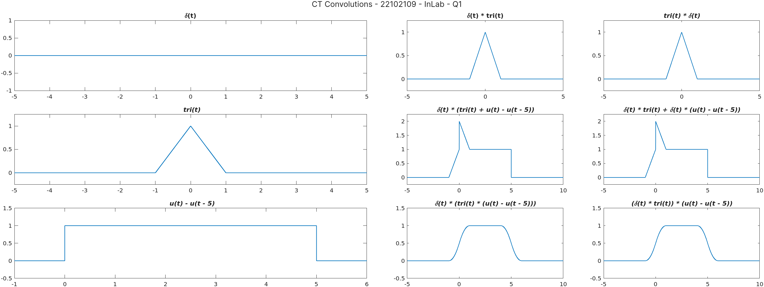

+-+-+-+-+-+-+-+-+-+-+-+-+-+-+-+-+-+-+-+-+-+-+-+-+-+-+-+-+-+-+-+-+-+-+-+-+-+-+

2. Using symbolics, generate one CT square signal and a unit impulse signal. Sketch and evaluate the convolution integral of these two signals and observe the result. Verify your answer using conv
clc;
clearvars;
syms t tau gamma;

% Declaring the symbolic functions to be used
square_wave = heaviside(t + 0.5) - heaviside(t - 0.5);
impulse = dirac(t);

% Plotting the base functions
my_tile = tiledlayout(2,2);
title(my_tile, "\fontname{Inter}CT Convolutions - 22102109 - InLab - Q2");
nexttile(1);
fplot(square_wave, [-1.75 1.75]);
ylim([-0.25 1.25]);
title("\it Square Wave");

nexttile(3);
fplot(impulse);
title("\it \delta(t)")

% Continuous Convolution Integral
clearvars square_wave impulse;
f_1_tau = heaviside(tau + 0.5) - heaviside(tau - 0.5);
f_2_minus = dirac(t - tau);
conv_1 = int(f_1_tau * f_2_minus, tau, -Inf, Inf);
disp(conv_1)
nexttile(2);
fplot(conv_1);
ylim([-0.25 1.25]);
title("\it Continuous Convolution using symbolic")

% Discrete Approximation in order to use conv()
n = -5:0.05:5;
f_1_dt = (abs(n) <= 0.5);
f_2_dt = (n == 0);
ct_conv = conv(f_1_dt, f_2_dt);
nexttile(4);
plot(-5:0.025:5, ct_conv);
ylim([-0.25 1.25]);
title("\it DT Approximation using conv")
clearvars;

OUTPUT:
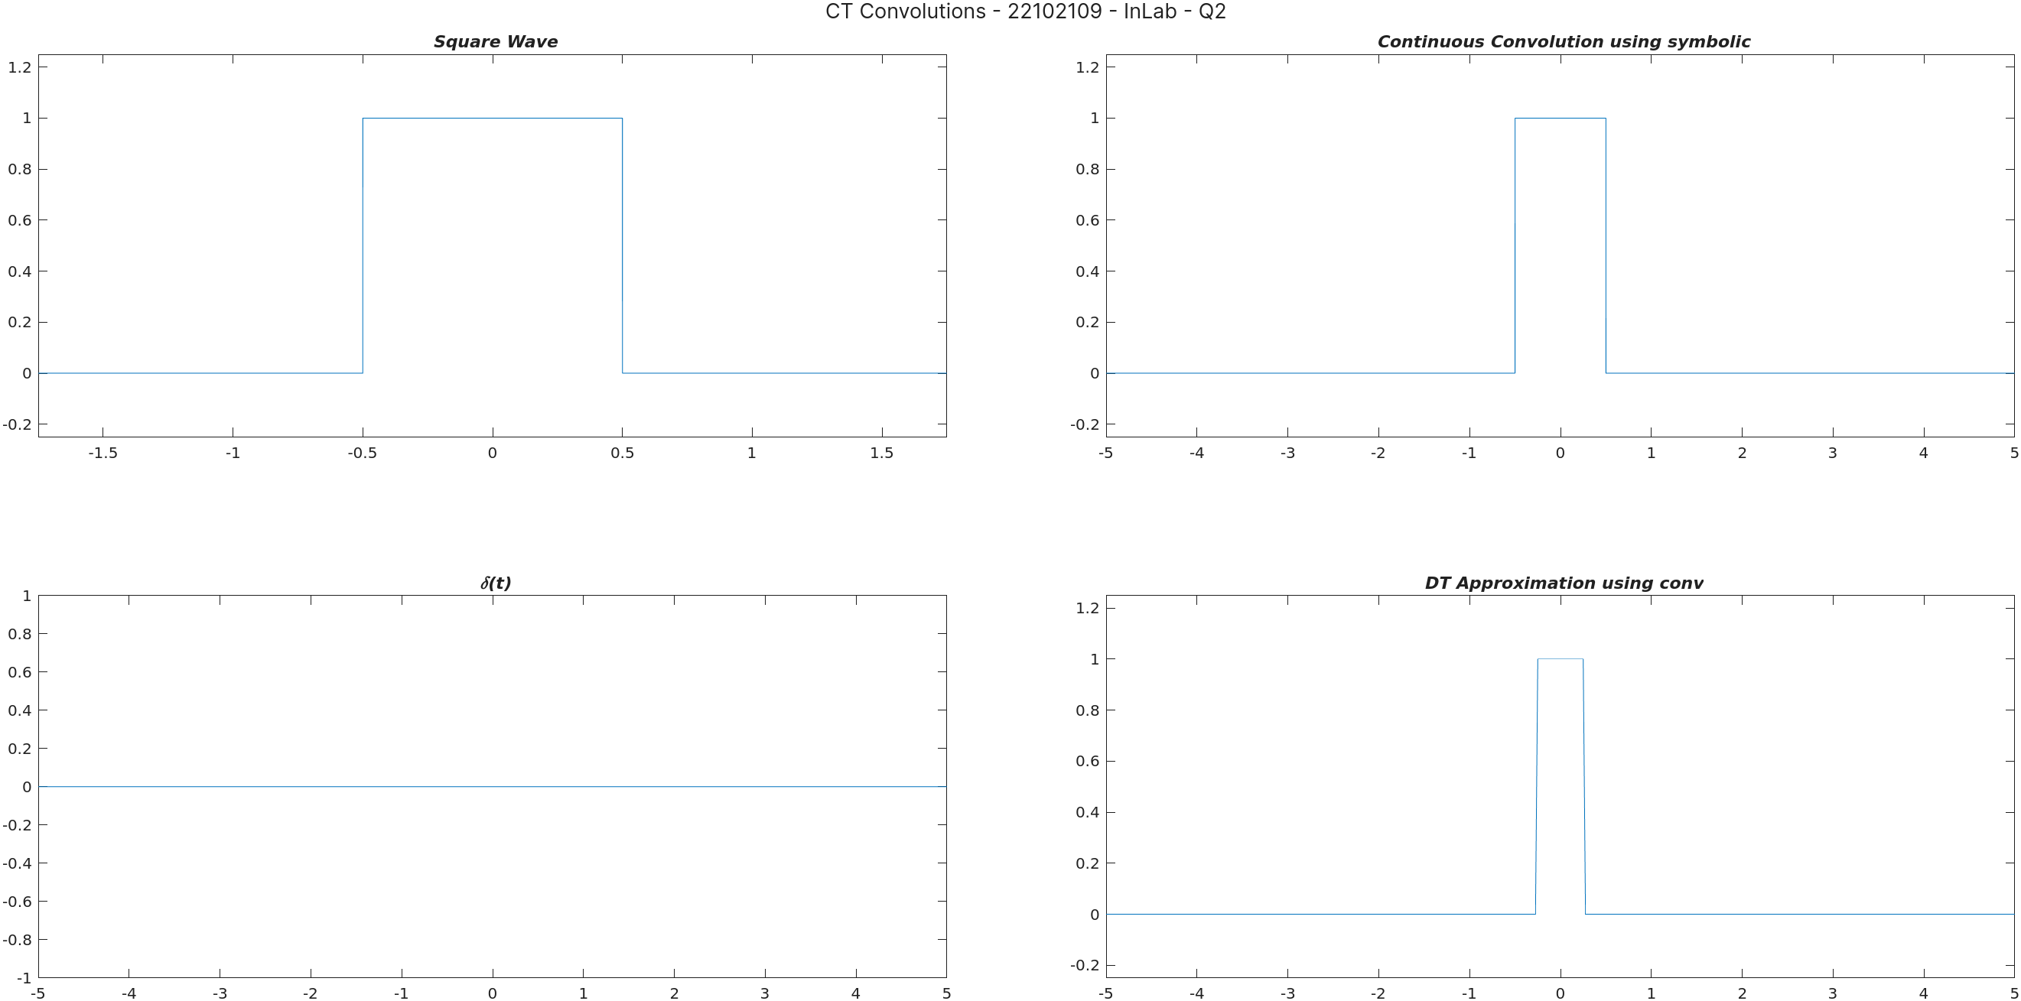
+-+-+-+-+-+-+-+-+-+-+-+-+-+-+-+-+-+-+-+-+-+-+-+-+-+-+-+-+-+-+-+-+-+-+-+-+-+-+

3. Using symbolics, generate one CT square and a unit impulse signal. Sketch and evaluate the convolution integral of these two signals and observe the result. Verify your answer using conv.

clc;
clearvars;
syms t tau;

% Declaring the symbolic functions to be used
square_wave = heaviside(t + 0.5) - heaviside(t - 0.5);
tri = triangularPulse(t);

% Plotting the base functions
my_tile = tiledlayout(2,2);
title(my_tile, "\fontname{Inter}CT Convolutions - 22102109 - InLab - Q3");
nexttile(1);
fplot(square_wave, [-1.75 1.75]);
ylim([-0.25 1.25]);
title("\it Square Wave");

nexttile(3);
fplot(tri);
ylim([-0.25 1.25]);
title("\it tri(t)");

% Continuous Convolution Integral
clearvars square_wave tri;
f_1_tau = heaviside(tau + 0.5) - heaviside(tau - 0.5);
f_2_minus = triangularPulse(t - tau);
conv_1 = int(f_1_tau * f_2_minus, tau, -Inf, Inf);
disp(conv_1)
nexttile(2);
fplot(conv_1);
ylim([-0.25 1.25]);
title("\it Continuous Convolution using symbolic")

% Discrete Approximation in order to use conv()
n = -5:0.05:5;
f_1_dt = (abs(n) <= 0.5);
f_2_dt = triangularPulse(n);
ct_conv = conv(f_1_dt, f_2_dt);
ct_conv = ct_conv / 20;
nexttile(4);
plot(-5:0.025:5, ct_conv);
ylim([-0.25 1.25]);
title("\it DT Approximation using conv")
clearvars;

OUTPUT
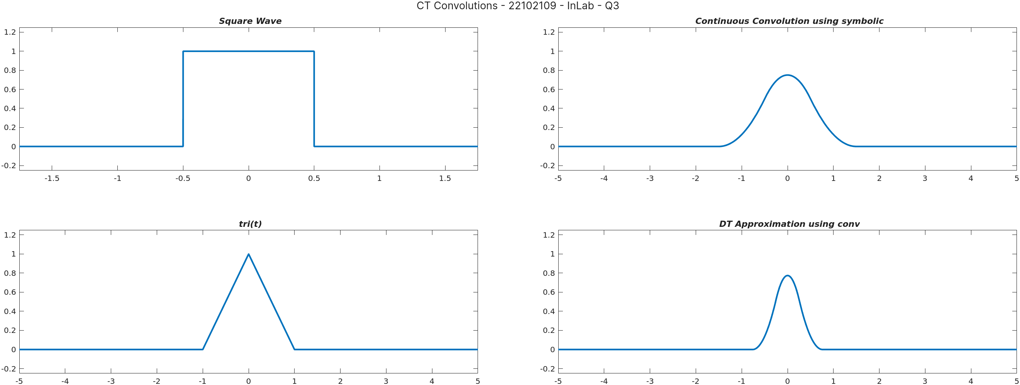
+-+-+-+-+-+-+-+-+-+-+-+-+-+-+-+-+-+-+-+-+-+-+-+-+-+-+-+-+-+-+-+-+-+-+-+-+-+-+

4. The impulse response of a given system is . Using symbolics, determine the output, y(t) due to input, . Sketch output and verify your answer using conv.

clc;
clearvars;
syms t tau gamma;

% Declaring the symbolic function to be used
h_t = exp(-t) * heaviside(t);
x_t = heaviside(t) - heaviside(t - 1);

% Plotting the functions
my_tile = tiledlayout(2,2);
title(my_tile, "\fontname{Inter}CT Convolutions - 22102109 - InLab - Q4");
nexttile(1);
fplot(h_t);
ylim([-0.25 1.25]);
title("\it e^{-t}u(t)");

nexttile(3);
fplot(x_t);
ylim([-0.25 1.25]);
xlim([-1.5 1.5])
title("\it u(t) - u(t - 1)");

% Continuous Convolution Integral
clearvars h_t x_t;
f_1_tau = exp(-tau) * heaviside(tau);
f_2_minus = heaviside(t - tau) - heaviside(t - tau - 1);
conv_1 = int(f_1_tau * f_2_minus, tau, -Inf, Inf);
disp(conv_1)
nexttile(2);
fplot(conv_1);
ylim([-0.25 1.25]);
title("\it Continuous Convolution using symbolic")

% Discrete Approximation in order to use conv()
n = -5:0.005:5;
f_1_dt = exp(-n) .* heaviside(n);
f_2_dt = heaviside(n) - heaviside(n - 1);
ct_conv = conv(f_1_dt, f_2_dt);
ct_conv = ct_conv / 200;
nexttile(4);
plot(-5:0.0025:5, ct_conv);
ylim([-0.25 1.25]);
title("\it DT Approximation using conv")
clearvars;

OUTPUT:
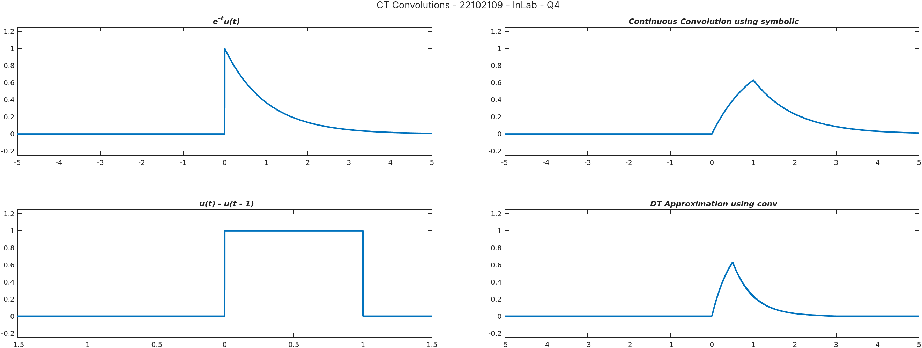

=============================================================================

POST LAB EXERCISES

1. Compute the convolution integral y(t) = x(t) * h(t) of the following pairs of signals:

- and depicted below:

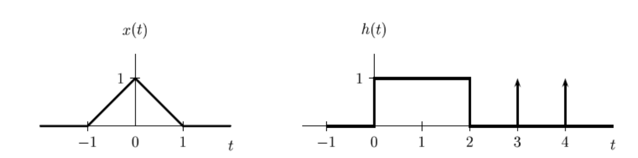

clc;
clearvars;
syms t tau;

my_tile = tiledlayout(2,3);
title(my_tile, "CT Convolutions - 22102109 - PostLab - Q1");

% Part a
x_t = exp(-3 * t) * heaviside(t);
h_t = heaviside(t + 3);
nexttile(1);
fplot(x_t);
ylim([-0.25 1.25]);
title("\it e^{-3t}u(t)");

nexttile(2);
fplot(h_t);
ylim([-0.25 1.25]);
title("\it u(t + 3)");

clearvars x_t h_t;
x_t = exp(-3 * tau) * heaviside(tau);
h_t = heaviside(t - tau + 3);
the_conv = int(x_t * h_t, tau, -Inf, Inf);
nexttile(3);
fplot(the_conv);
ylim([-0.05 0.4]);
title("\it e^{-3t}u(t) * u(t + 3)");

% Part b
clearvars x_t h_t;
x_t = triangularPulse(t);
h_t = heaviside(t) - heaviside(t - 2) + dirac(t - 3) + dirac(t - 4);
nexttile(4);
fplot(x_t);
ylim([-0.25 1.25]);
title("\it tri(t)");

nexttile(5);
fplot(h_t);
ylim([-0.25 1.25]);
title("\it u(t) - u(t - 2) + \delta(t - 3) + \delta(t - 4)");

clearvars x_t h_t;
x_t = triangularPulse(tau);
h_t = heaviside(t - tau) - heaviside(t - tau - 2);
h_t = h_t + dirac(t - tau - 3) + dirac(t - tau - 4);
the_conv = int(x_t * h_t, tau, -Inf, Inf);
nexttile(6);
fplot(the_conv, [-2 6]);
ylim([-0.25 1.25]);
title("\it x(t) * h(t)");
clearvars;

OUTPUT:
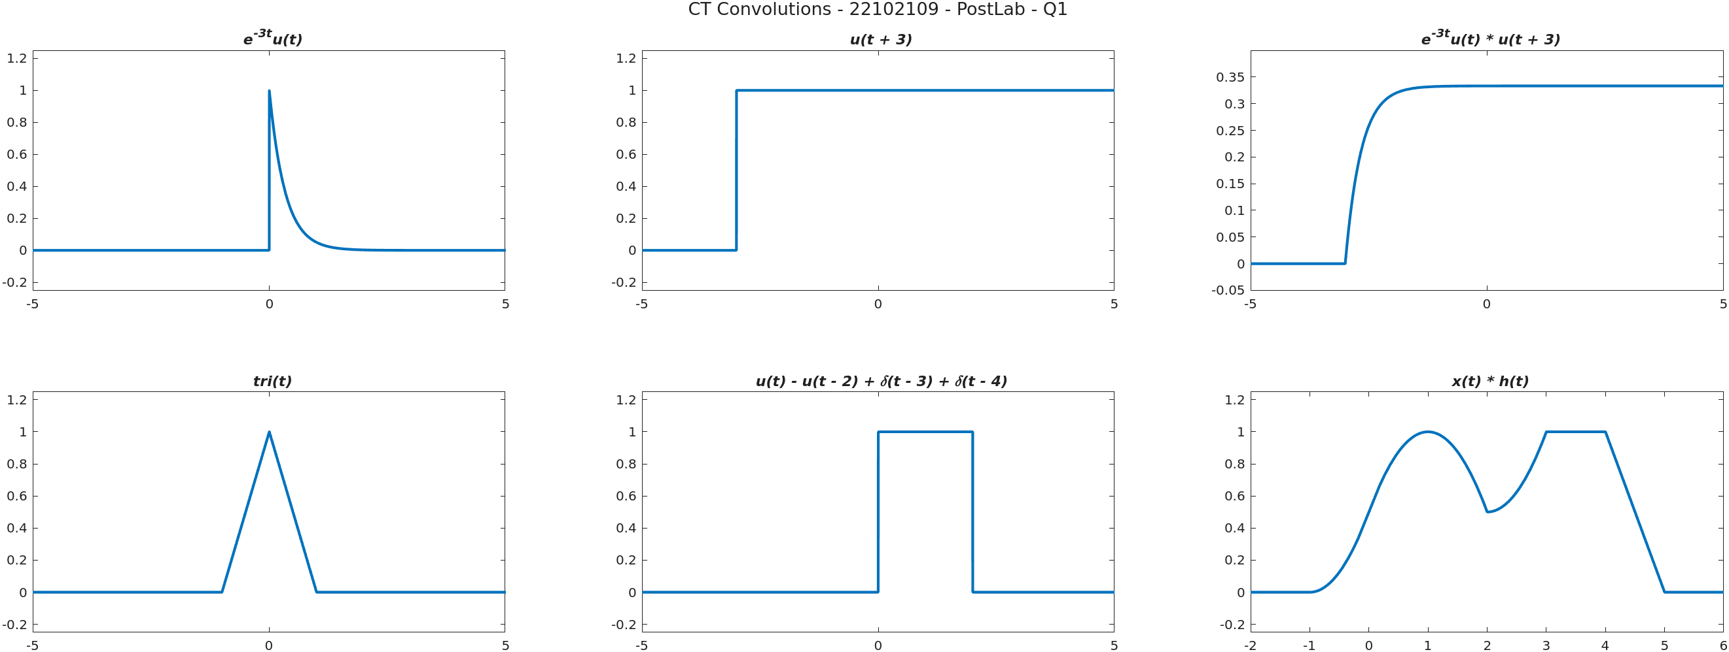

+-+-+-+-+-+-+-+-+-+-+-+-+-+-+-+-+-+-+-+-+-+-+-+-+-+-+-+-+-+-+-+-+-+-+-+-+-+-+

2. Calculate convolution sum of and .

clc;
clearvars;
syms t tau;

my_tile = tiledlayout(1,3);
title(my_tile, "CT Convolutions - 22102109 - PostLab - Q2");

% Plotting the base functions
x_t = heaviside(t) - heaviside(t - 2);
h_t = exp(-t) * heaviside(t);
nexttile(1);
fplot(x_t);
ylim([-0.25 1.25]);
title("\it u(t) - u(t - 2)");

nexttile(2);
fplot(h_t);
xlim([-0.25 5]);
ylim([-0.25 1.25]);
title("\it e^{-t}u(t)");

clearvars x_t h_t;
x_t = heaviside(tau) - heaviside(tau - 2);
h_t = exp(-(t - tau)) * heaviside(t - tau);
the_conv = int(x_t * h_t, tau, -Inf, Inf);
nexttile(3);
fplot(the_conv);
ylim([-0.25 1.25]);
title("\it x(t) * h(t)");

OUTPUT:
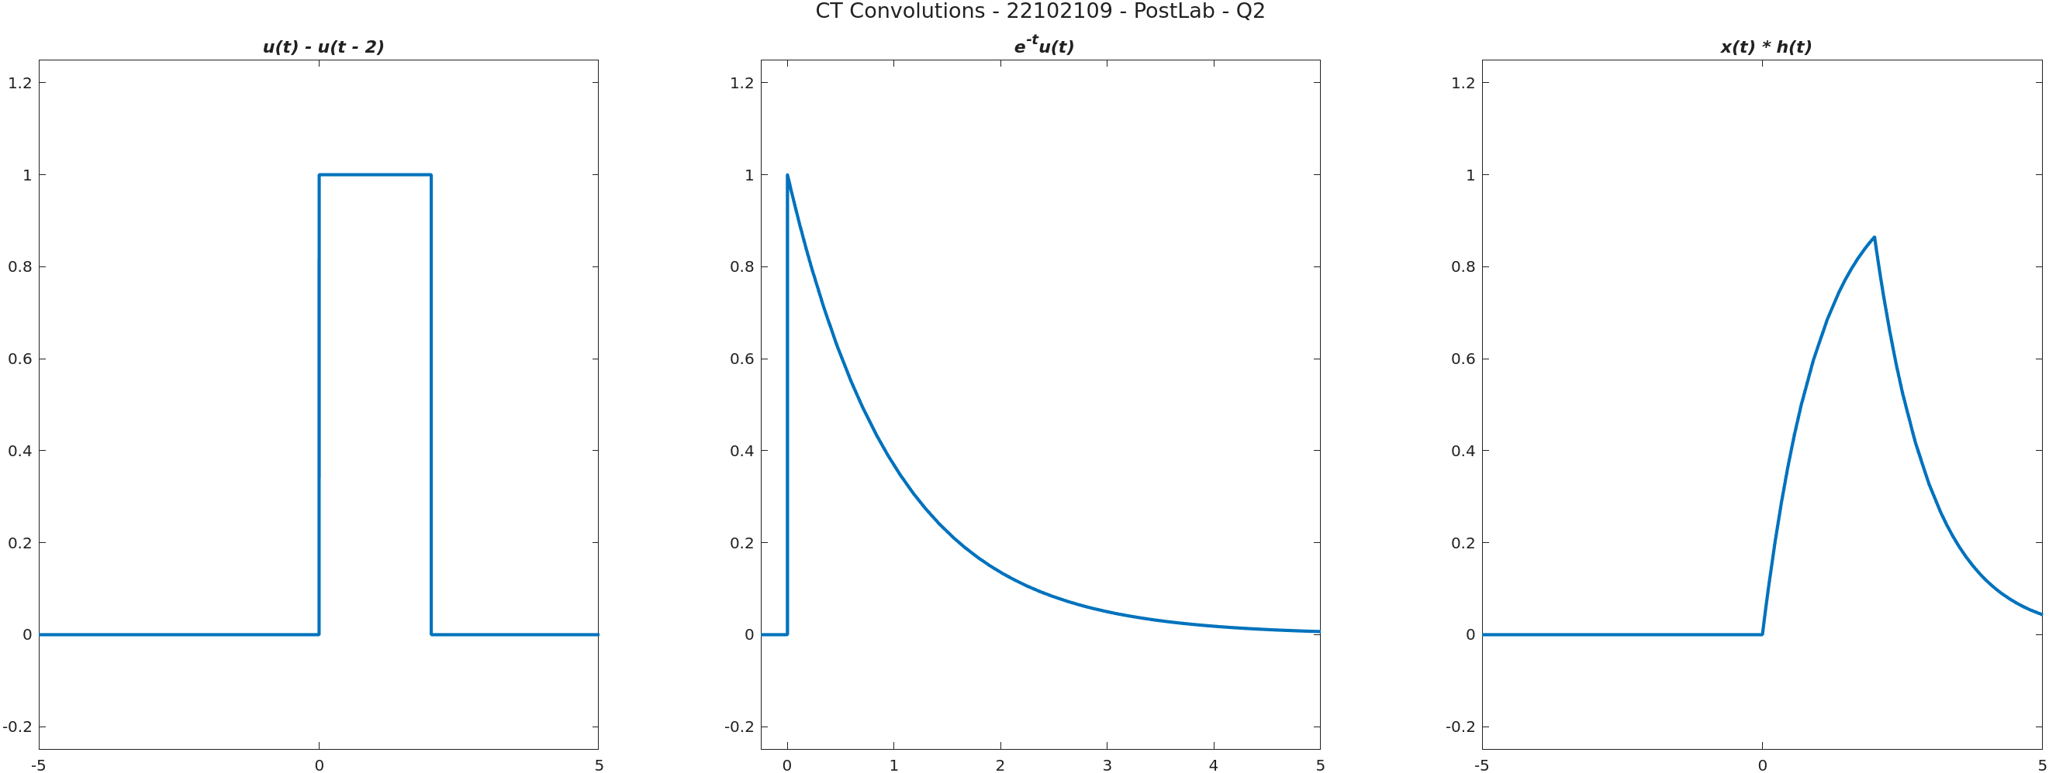

=============================================================================

RESULT: In the MATLAB experiment, the convolution sum of two continuous time signals was successfully computed. The result represents the output signal formed by convolving the input signals, demonstrating the linear time-invariant system's response.

LEARNING OUTCOME: Learning Outcomes of this experiment are:
- Developing proficiency in using MATLAB for signal processing tasks.
- Gaining practical experience in convolving discrete time signals.
- Insight into how convolution affects signal characteristics.
- Real-world application of convolution in filtering and system analysis.

